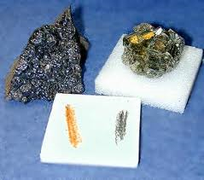
Physical Characteristics of Minerals

A mineral is an _______________ substance found naturally on the Earth’s crust. All minerals are ___________ but not all ___________ are minerals.

Inorganic means __________________________________________________________
________________________________________________________________________
Crystals are ______________________________________________________________
________________________________________________________________________

Minerals can be characterised by their physical properties:

1. Colour: Explain how colour can be used to identify minerals. _________________
________________________________________________________________________
________________________________________________________________________
Green and blue often indicate ____________ whilst red usually indicates ____________.
Is colour a good way to identify minerals? Why? ________________________________
________________________________________________________________________

2. Streak: This is the colour of the _____________ mineral. This colour can be quite
_________________ from the parent rock.
Explain how you test for streak. _____________________________________________
_______________________________________________________________________
Is streak the same as colour? ______________________

3. Cleavage: Explain what cleavage in minerals means. ______________________
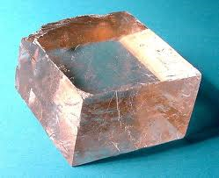
________________________________________________________________________ This is due to the bonding between molecules. __________ has one cleavage plane which breaks it into flat sheets. ________ pyrites (fool’s gold) has six which break it into cubic prisms.
Draw some examples of different forms of cleavage in minerals.

4. Magnetism: Explain what magnetism means. _____________________________
________________________________________________________________________
How do you test for it? _____________________________________________________
5. Lustre: Explain what lustre is. _________________________________________
_______________________________________________________________________
_______________________________________________________________________
Describe three of the terms used to identify lustre. Eg earthy. ______________________
________________________________________________________________________
________________________________________________________________________

6. Crystalline Habit: Explain the crystalline habit of different minerals. __________
________________________________________________________________________
________________________________________________________________________
Draw three different crystal forms.

7. Hardness: Describe hardness of a mineral. _______________________________
________________________________________________________________________

Complete the Moh’s Hardness Scale:
1 | Talc | 6
2 |  | 7
3 |  | 8
4 |  | 9 | Corundum
5 |  | 10

8. Specific Gravity: Explain specific gravity. _______________________________
________________________________________________________________________
________________________________________________________________________
________________________________________________________________________________________________________________________________________________________________________________________________________________________



